**Project Proposal**

# Overview:

* ***Business objective:*** Leverage deep analytics on customer data to:
  + better understand customer transaction patterns
  + capitalize on business development opportunities and leads
* ***Methodology:*** Develop customer-specific algorithms on a sample of S3/S4 customers to:
  + Identify the right branch & day/time to setup appointments
  + Identify the suitable offerings (products, service initiatives, etc.) to discuss during the appointment
* ***Expected annual benefits:*** Improvement in customer engagement and share of wallet thru:
  + Increase in success rate of setting up appointments (from 5-15% today to 20-25%)
  + Increase in conversion of presentation (post setting up of appointment)

# Analysis based on the country selected:

**Need Help from my Thai colleagues for this. But these are Singapore Numbers**

**For 52 of 58 branches, more than 50% of PFS customers don’t transact where they live**

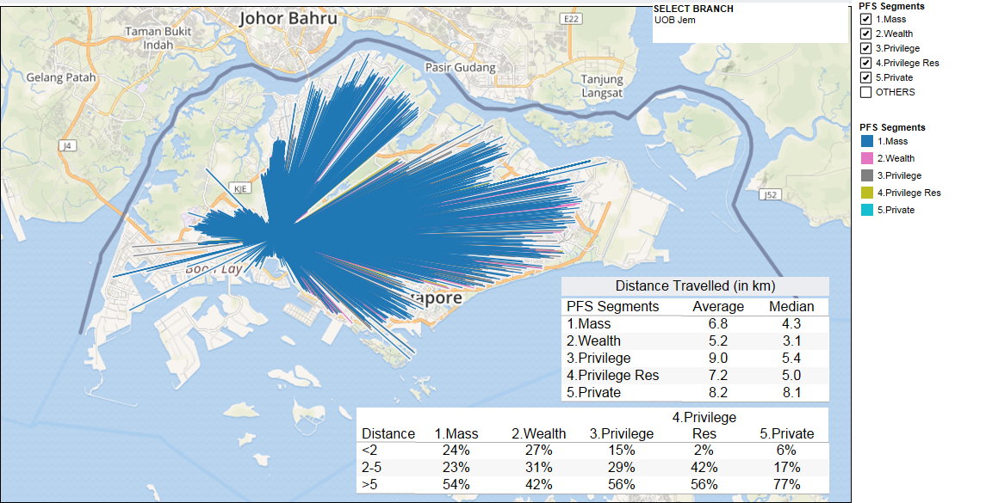

With thai numbers, I can apply a similar logic to get the Incremental Annual Review.

# Areas of interest and the reasons for choosing the project (in terms of feasibility & relevance)

1. Area of Interest : Cross – Selling success rate by Personal Bankers to Mass Market customers :
2. Reason for choosing project :
   * Conventionally, personal bankers (PB) are assigned a list of customers to cold call and try to arrange an appointment with them.
   * Current process of assigning leads – based on customer’s registered address or domicile account branches.
   * Challenge – The success rate of setting up appointments is low (5-15% based on anecdotal evidence).
   * Insights from Pattern of Life – A number of customers conduct banking transactions near their work location / points of leisure (which are not very close to their registered address or that of domicile account branch).

# Project description/concept on how the project is going to help the identified group or organization.

1. The possibility of setting up appointment can be higher if we study customer transaction patterns to identify customer patterns better.
2. Conversion rate of products attempted to be sold will be higher.
3. Customers will be face better and more targeted cod calls that really touch upon their needs and try to serve them at their convenience.

# The extent in which the project can increase business outreach or how can we make it business relevant.

|  |  |
| --- | --- |
| # of customers transacting at branches | 206,000 |
| # of customers transacting at SSBs  (those not going to branches) | 601,000 |
| # of customers targeted for cross-sell:  30% * (206k+601k) – conservative | 242,100 |
| # of customers identified from our recommendation:  66% * 242,100  (66%: 12/18 customers are assigned to a new branch) | 159,786 |
| Contact Rate | 70% |
| Incremental Appointment Rate  (Improved from 10% - 20%) | 10% |
| Conversion Rate – conservative | 20% |
| Average Revenue per sales | $400 |
| Incremental Annual Revenue | $894,802 |

# Estimated budget and manpower required

Assumption: We Ride on the new Data Warehouse being implemented bank wide.

Assumption : Data needed already exists

For POC

* + - Manpower : .8 people
    - Cost : $5000 ( Breakdown I will explain in person )

For Full Scale Implementation :

* + - Manpower : A full scale development team ( 8 people )
    - Cost
      * Labor : 60,000 per month
      * Storage : ?
      * Overheads : ?